**PROG8450- BIG DATA INTEGRATION**

**Analysis with Hive**

**AUTOR – ISLAMIYAT OSUOLALE**

**ID - 8773642**

**INTRODUCTION**

In this Assignment, we will be working with the car.csv dataset that you can  
download from https://www.kaggle.com/mirosval/personal-cars-classifieds or use  
the wget command provided which can directly load the dataset into HDFS.

This dataset has the classified records for several Eastern European countries over  
several years. Beware that the data is not “clean” and investigating and cleaning  
the data is an important part of the Assignment.

**PROBLEM BACKGROUND**

We are data analyst at a large investment firm that is contemplating to invest in  
a used car business. Our task here is to provide data driven advice to the stakeholders,  
that will enable them to make a sound investment decision. Failure to make the  
best decision may result in large financial consequences and irreversible damage to  
the company reputation and brand.  
Our manager has instructed us to use the cars.csv dataset, because the veracity  
of this data has been established.

TASKS:

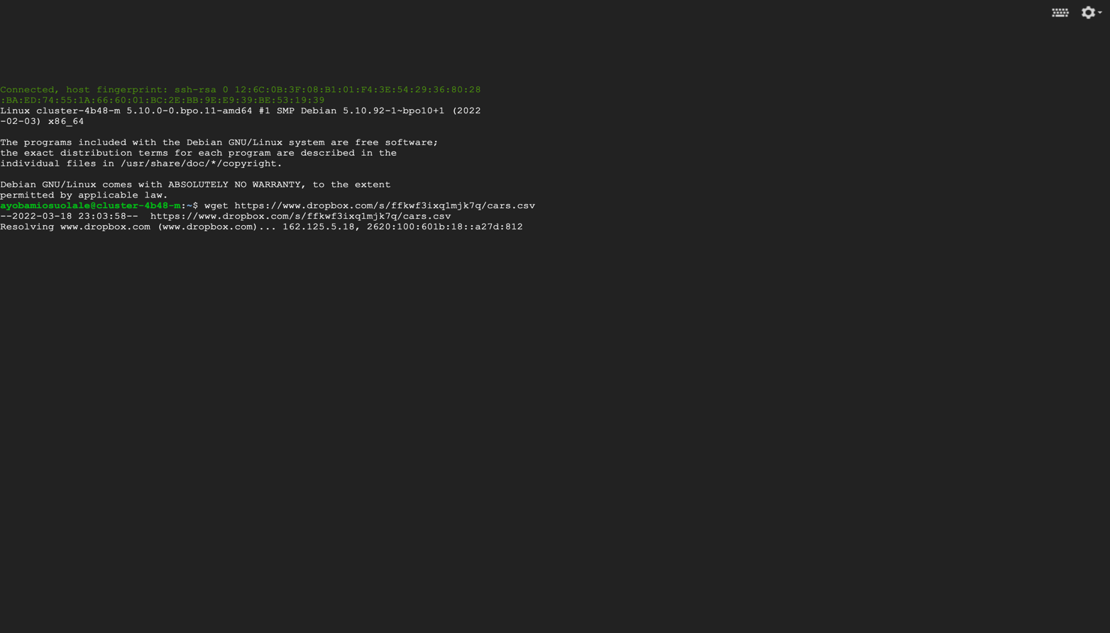

FIG. 1. IMPORTING DATASET INTO ROOT

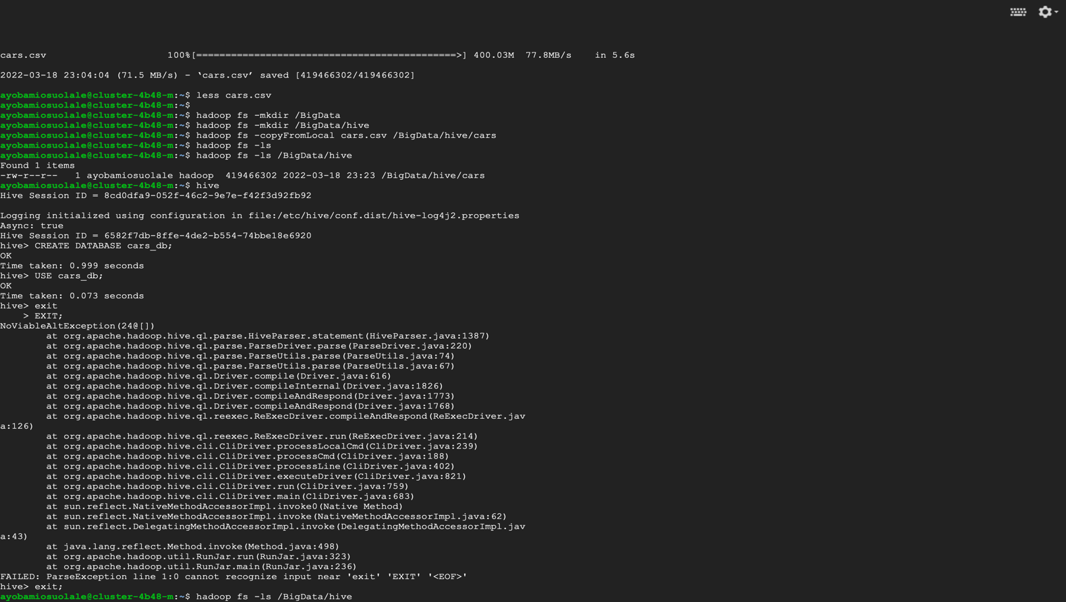

FIG. 2. CREATING FOLDERS AND IMPORTING THE DATASET IN ROOT

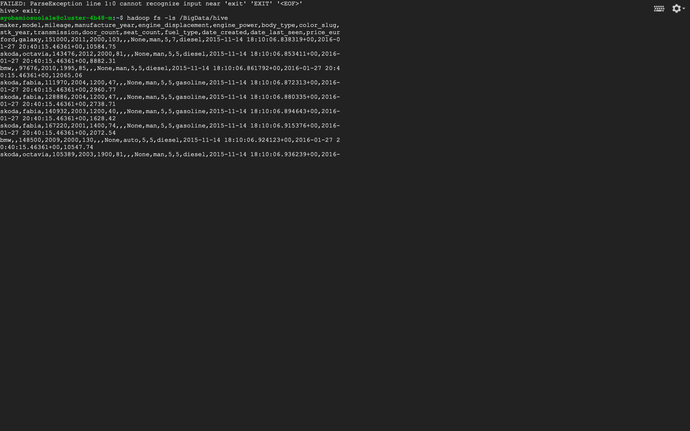

FIG. 3. ILLUSTRATES HOW OUR DATASET LOOK LIKE

1. Write a Hive query to create a table called used_cars from data. Use a schema that is  
   appropriate for the column headings

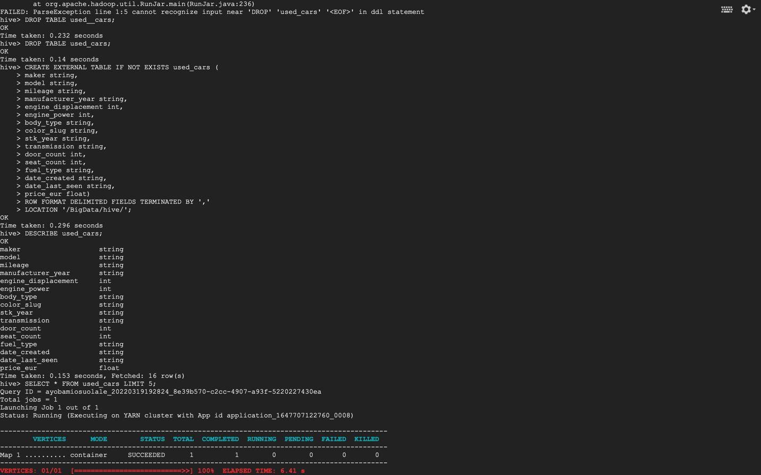

FIG. 4. CREATING AN EXTERNAL TABLE WITH THE RIGHT SCHEMA THAT FITS THE DATASET

1. Look at the date column of the table used_cars. Why does the date column have all  
   NULL values?

Checking our date format, it was in the right form we wanted it to be but we also want it in the date and time format, the figure below shows the query to solve it. We created a table for date.

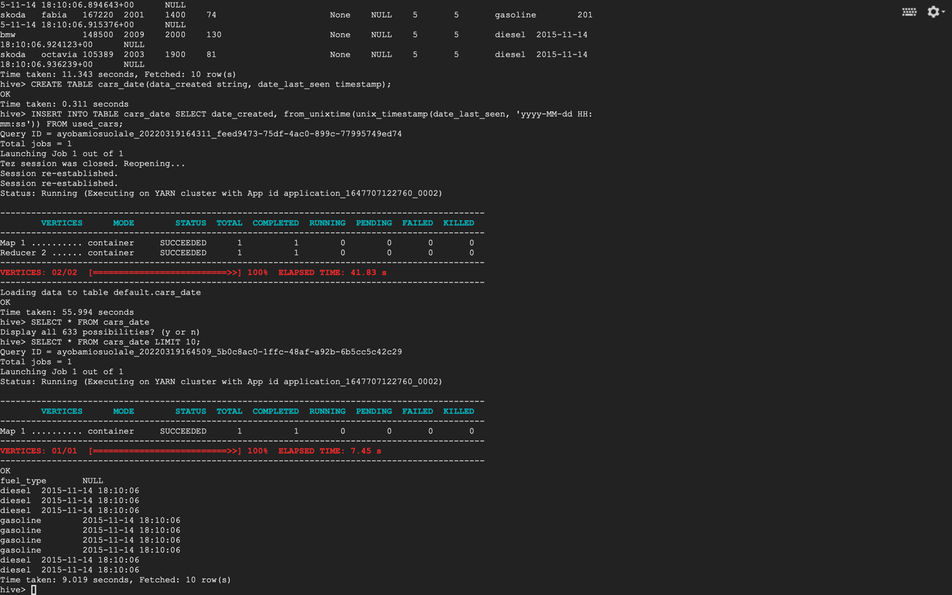

FIG. 5 CONVERTING DATE TO THE RIGHT FORMAT

1. In FIG. 6 we converted it using unixtimestamp and it changed the format and structure of date in our dataset.

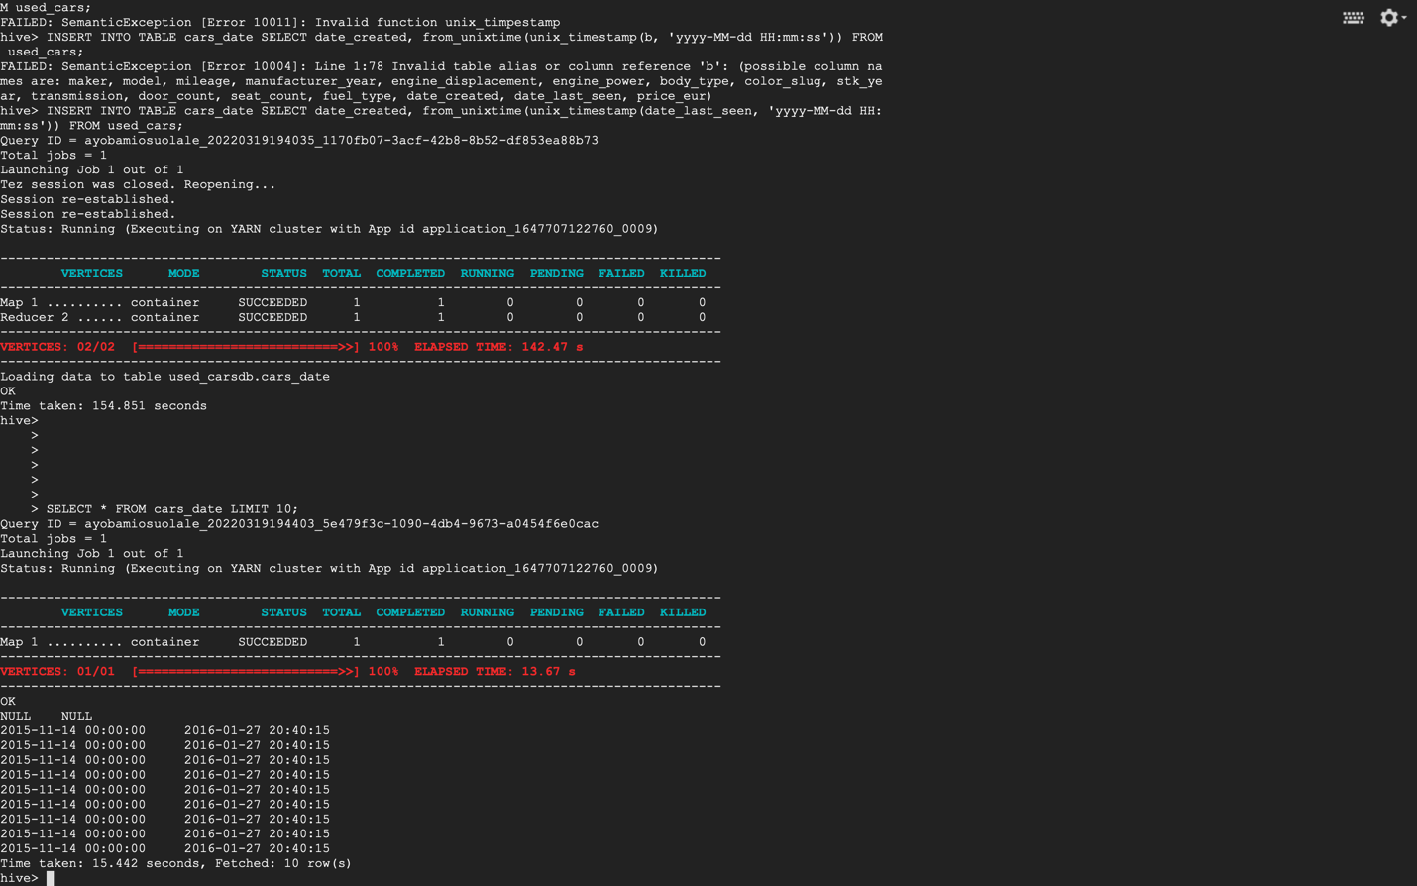

FIG. 6. INSERT INTO TABLE OF DATE, UNIX TIMESTAMP DATE FORMAT

1. Write Hive queries to see how many missing values you have in each attribute? Based  
   on the results, document how many missing values in each column we have. Especially,  
   mention those columns with more than 50% missing values.

Most of the columns have about 50% missing values in the data, it is a really big data with more than three million numbers of records in it. Kindly check APPENDIX for results of the numbers of missing values in each column.

1. Group the price column and count the number of unique prices. Do you notice if there  
   is a single price that is repeating across the ads?

Using SELECT method to display the count of the number of unique prices, see figure below.

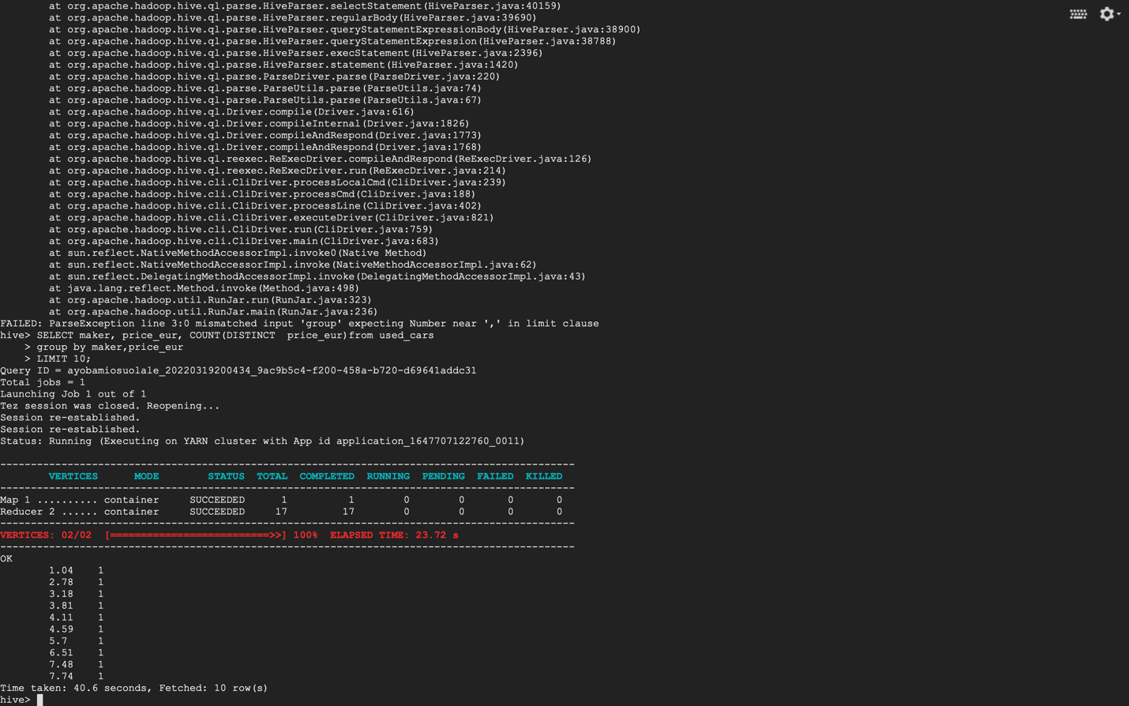

FIG. 7. SHOWS US THE UNIQUE VALUE OF PRICE WITH LIMIT OF 10 ROWS

1. Write a Hive query to create a new table called clean_used_cars from used_cars with  
   the following conditions:

* Drop the columns with more than 50% missing values
* The manufacture year between 2000 and 2017 including 2000 and 2017
* Both maker and model exist in the row
* The price range is from 3000 to 2000,000 (3000 ≤ price ≤ 2000,000)
* Remove any price you singled out in Step 3 (ie a price that repeats too frequently for  
  a random set of ads).

Solutions to this is solved across FIG.7- FIG. 11, even with so many errors and trying to debug the codes in hive, we still came out with a really close result to the question.

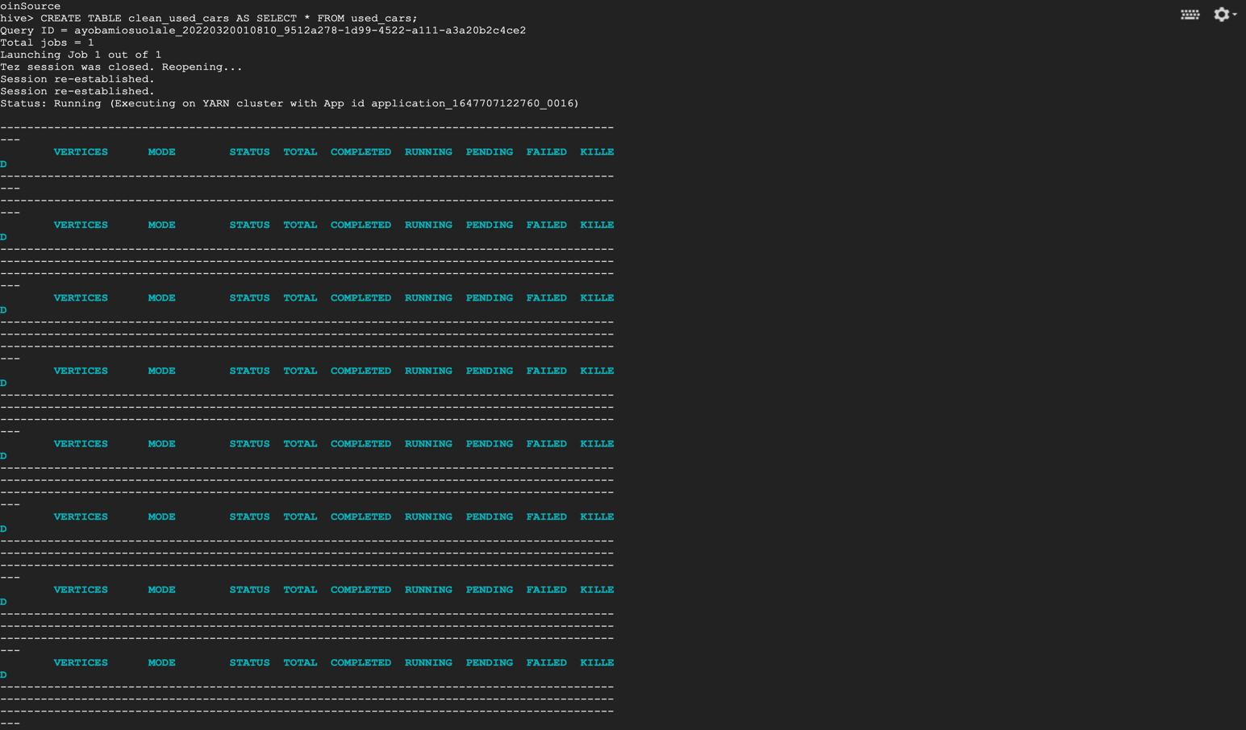

FIG. 8 CREATING A TABLE FROM ANOTHER TABLE USING SELECT STATEMENT

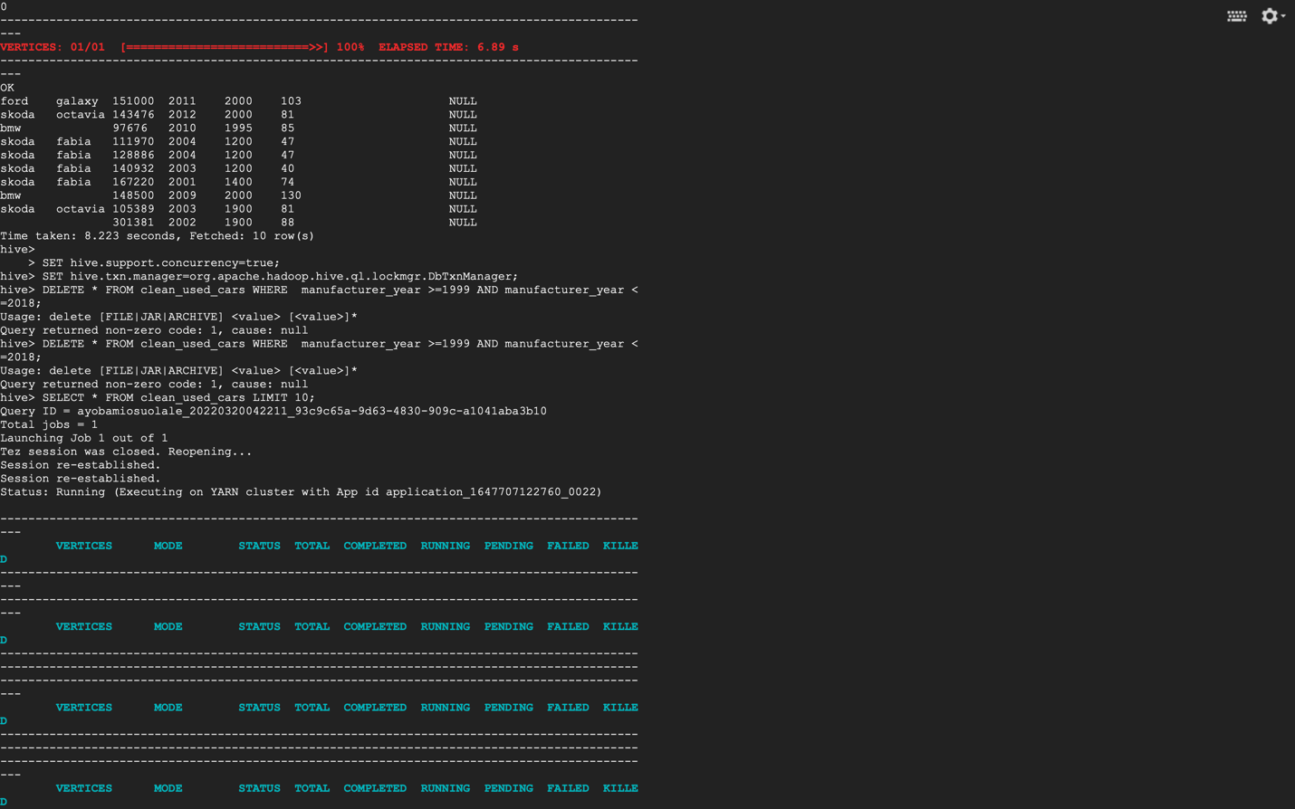

FIG. 9. DROPPING COLUMNS WITH THE CONDITIONS

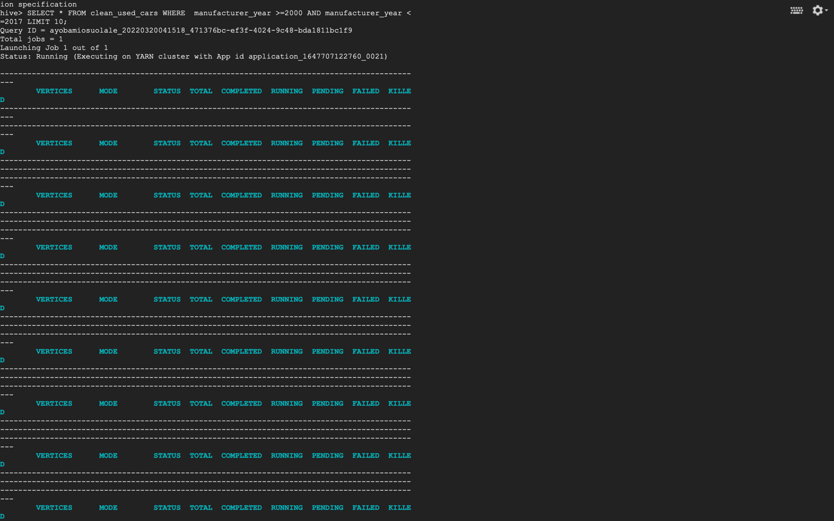

FIG. 10. QUERY TO CHECK PRICE RANGE

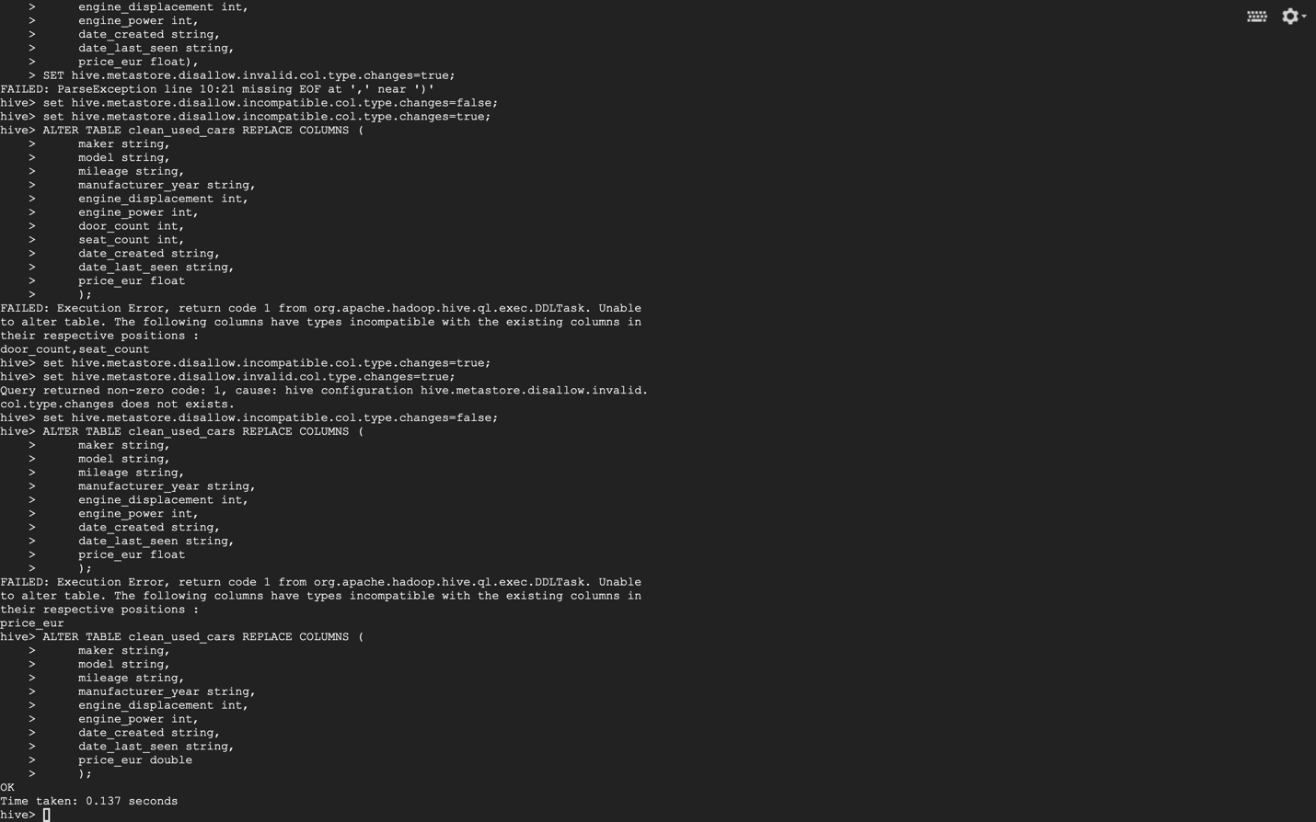

FIG. 11. ALTRING THE TABLE TO CHOOSE THE SPECIFIC COLUMNS WE WANT IN OUR CLEAN DATASET

1. Write a Hive query to find how many records remained clean_used_cars

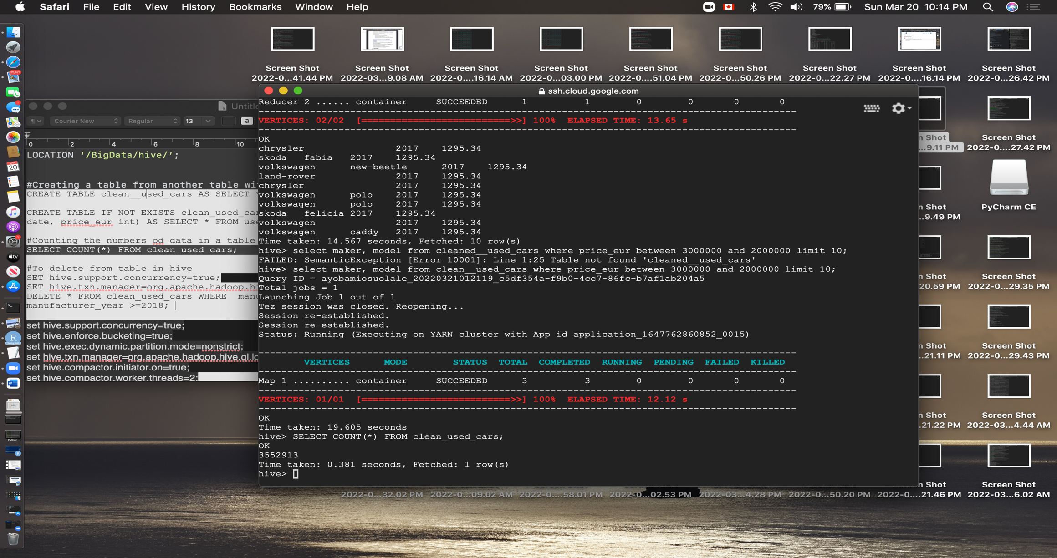

FIG. 12. WE CALCULATED THE NUMBER OF RECORDS WE HAVE IN OUR CLEAN DATA

1. Write a Hive query to find the make and model for the cars with the top 10 highest  
   average price
2. Write a Hive query to find the make and model for the cars with the top 10 lowest  
   average price

FIG.13 contains the query that displays the top ten highest and lowest average price of model and make.

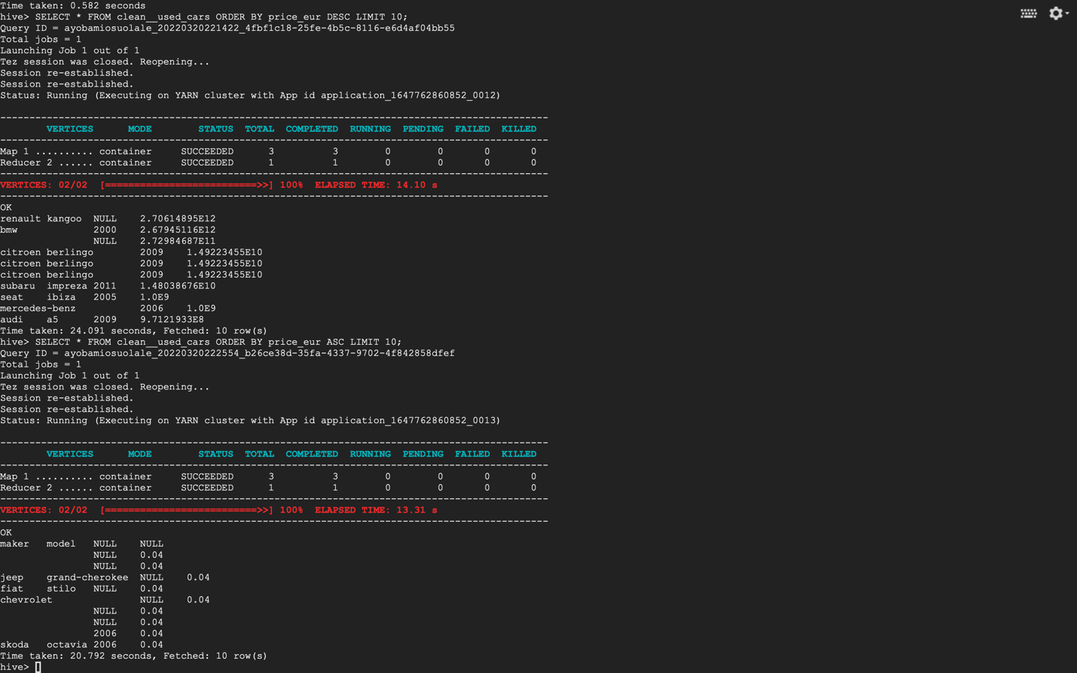

FIG. 13. SHOWS THE TOP TEN HIGHEST AND LOWEST AVERAGE PRICE OF MODEL AND MAKER

1. Write a Hive query to recommend top five make and model for Economic segment  
   customers (Top five manufacturers in the 3000 to 20,000 price range;3000≤price<20,000) -  
   based on the top average price

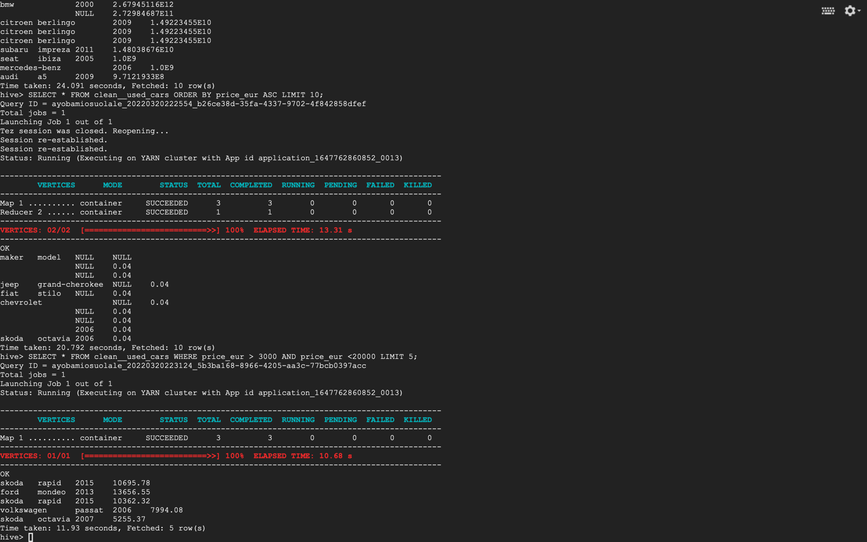

FIG. 14. FIVE MAKE AND MODEL FOR ECONOMIC SEGMENT

1. Write a Hive query to recommend top five make and model for Intermediate segment  
   customers (Top five manufacturers in the 20,000 to 300,000 price range;  
   3000≤price<20,000) - based on the top average price
2. Write a Hive query to recommend the top five make and model for the Luxury segment  
   customers (Top five manufacturers in the 300,000 to 2000,000 price range;  
   300,000≤price<2000,000) - based on the top average price

For questions 11 and 12, see FIG. 15.

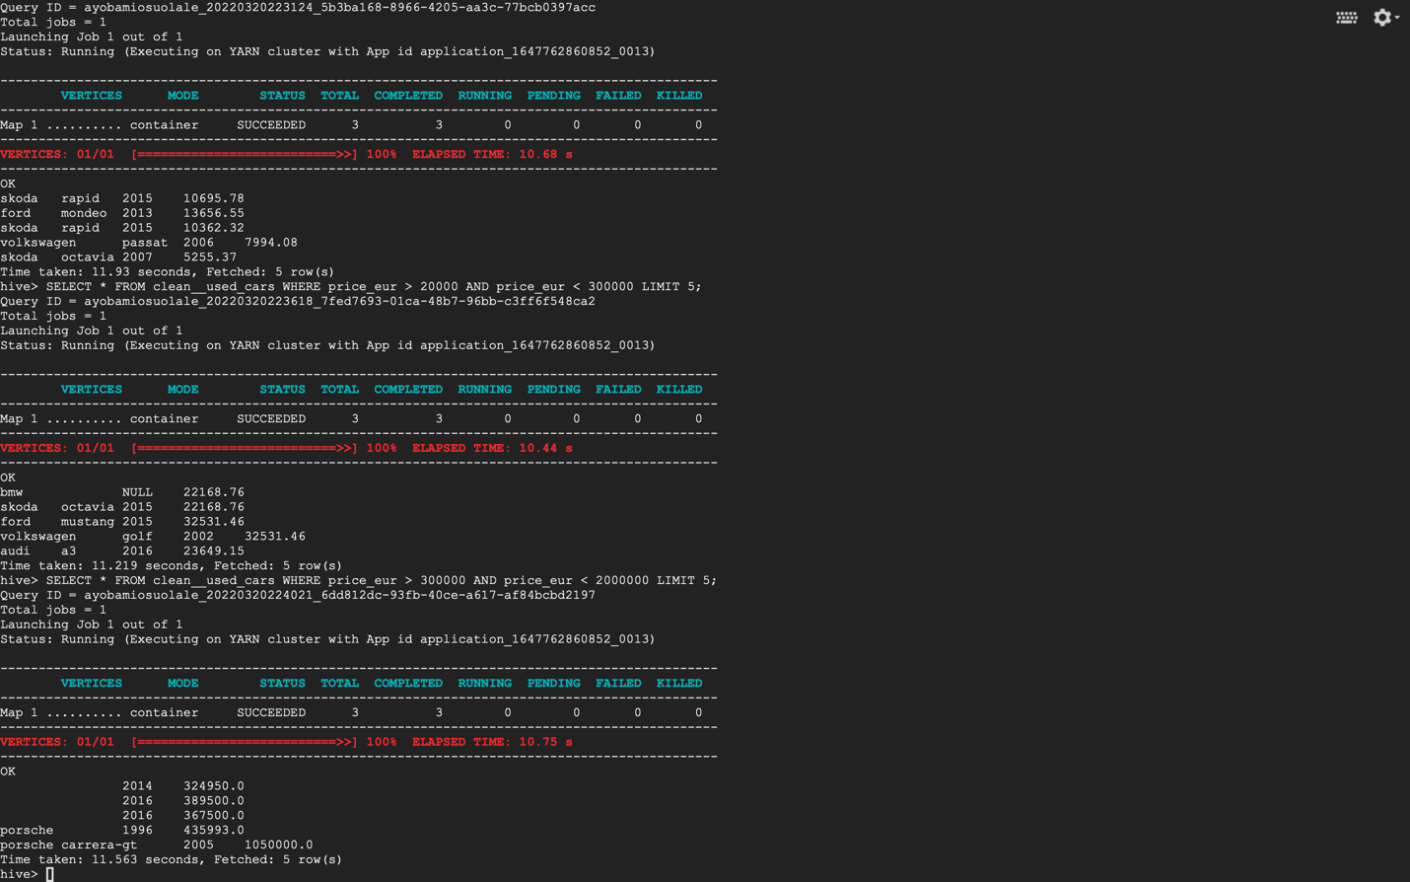

FIG. 15. DISPLAYS THE ANWERS TO QUESTION 11 AND 12

**APPENDIX**

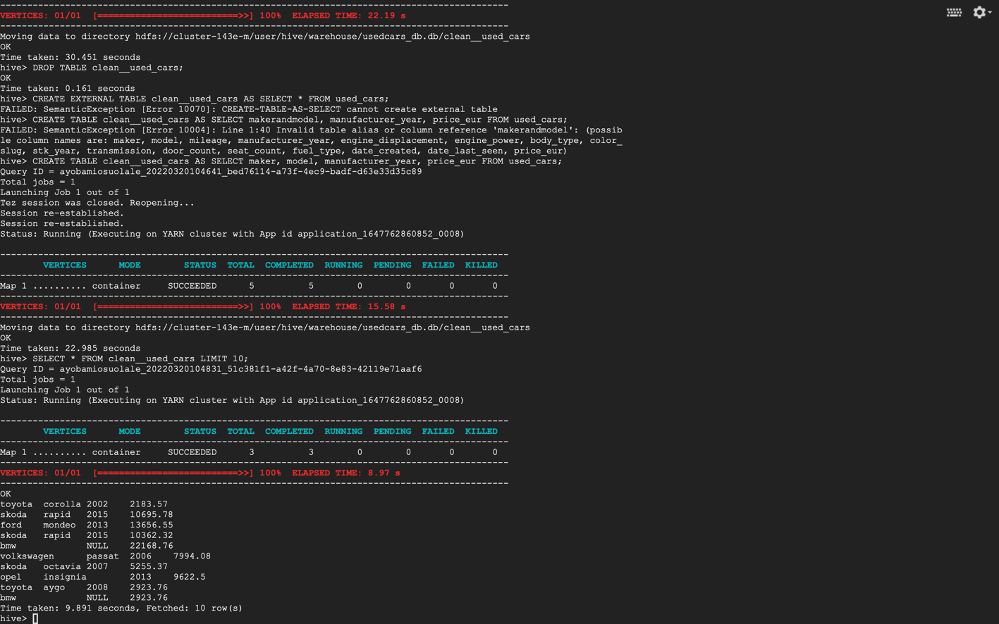

FIG. 1 2ND FORMAT OF CREATING TABLE FROM ANOTHER TABLE

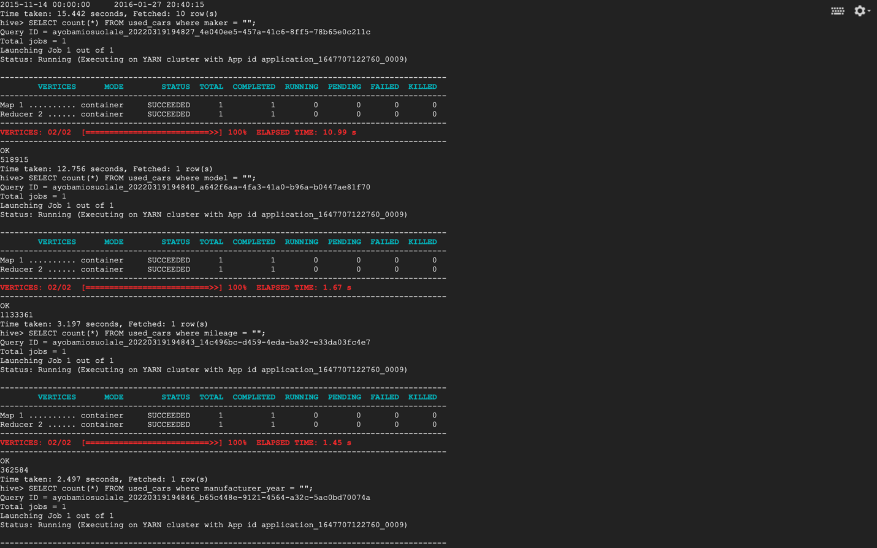

FIG. 2 CALCULATE NULL IN COLUMNS

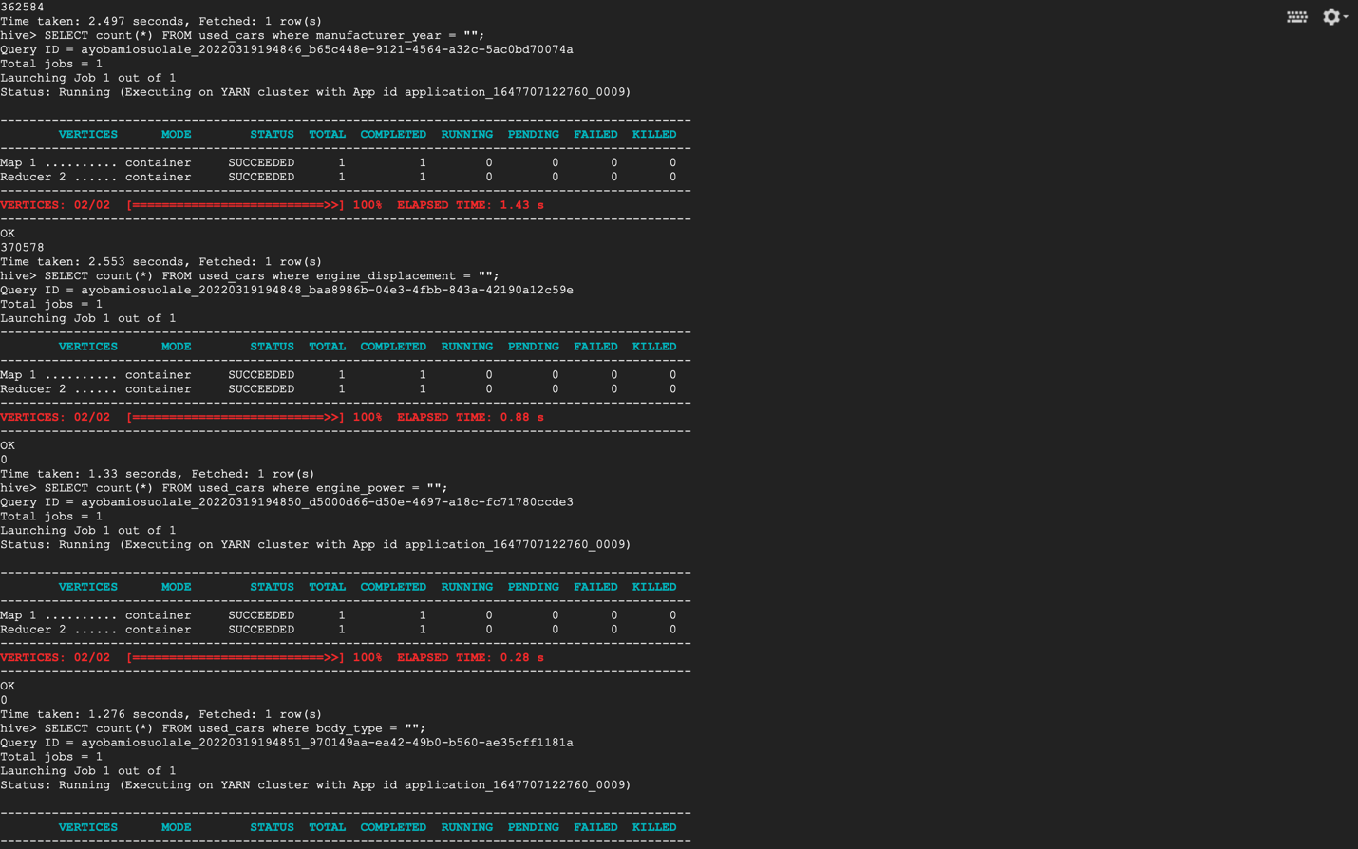

FIG. 3. CALCULATE NULL IN COLUMNS

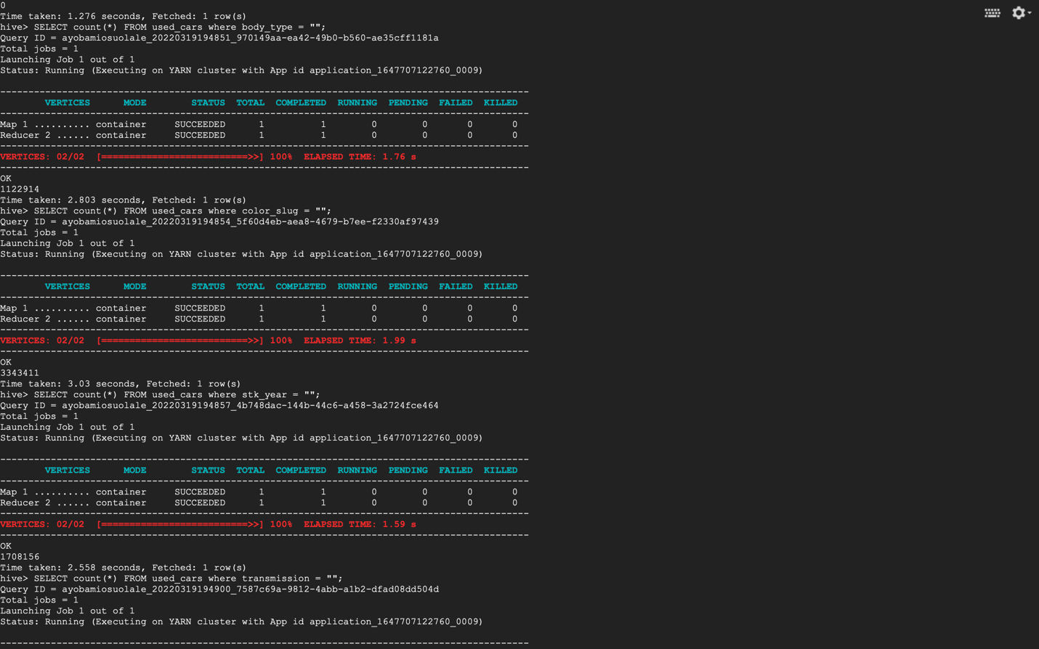

FIG. 4. CALCULATE NULL IN COLUMNS

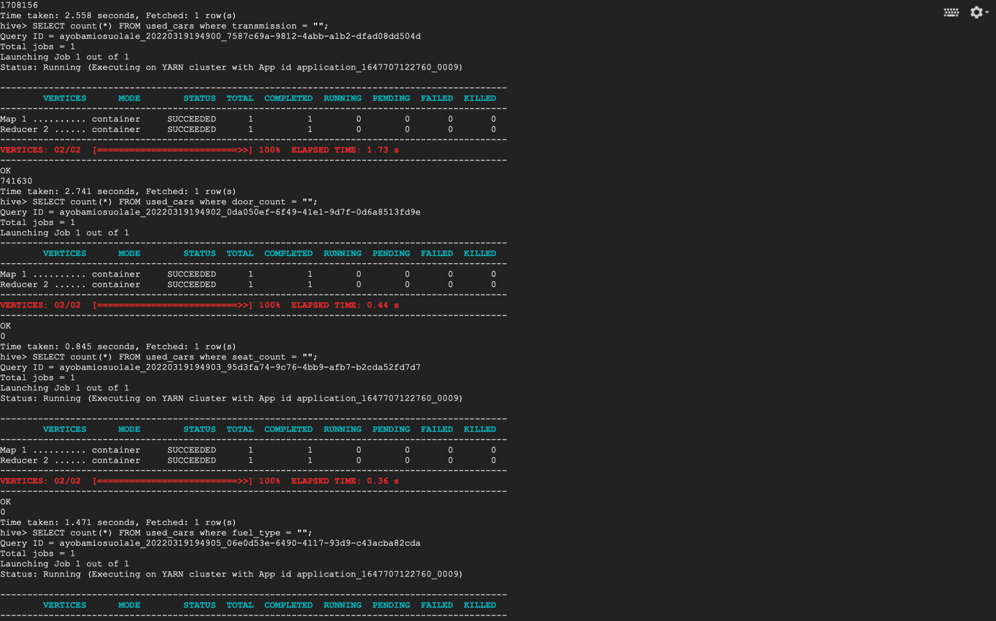

FIG. 5. CALCULATE NULL IN COLUMNS

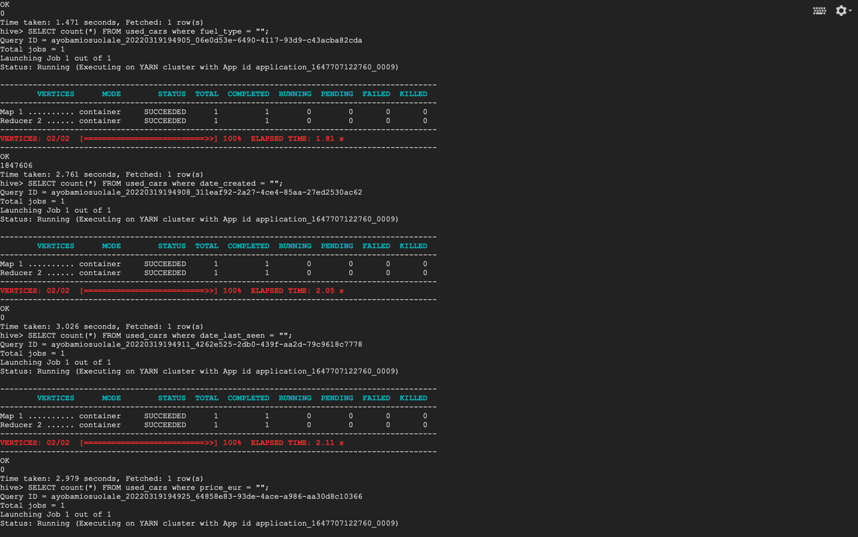

FIG. 6. CALCULATE NULL IN COLUMNS

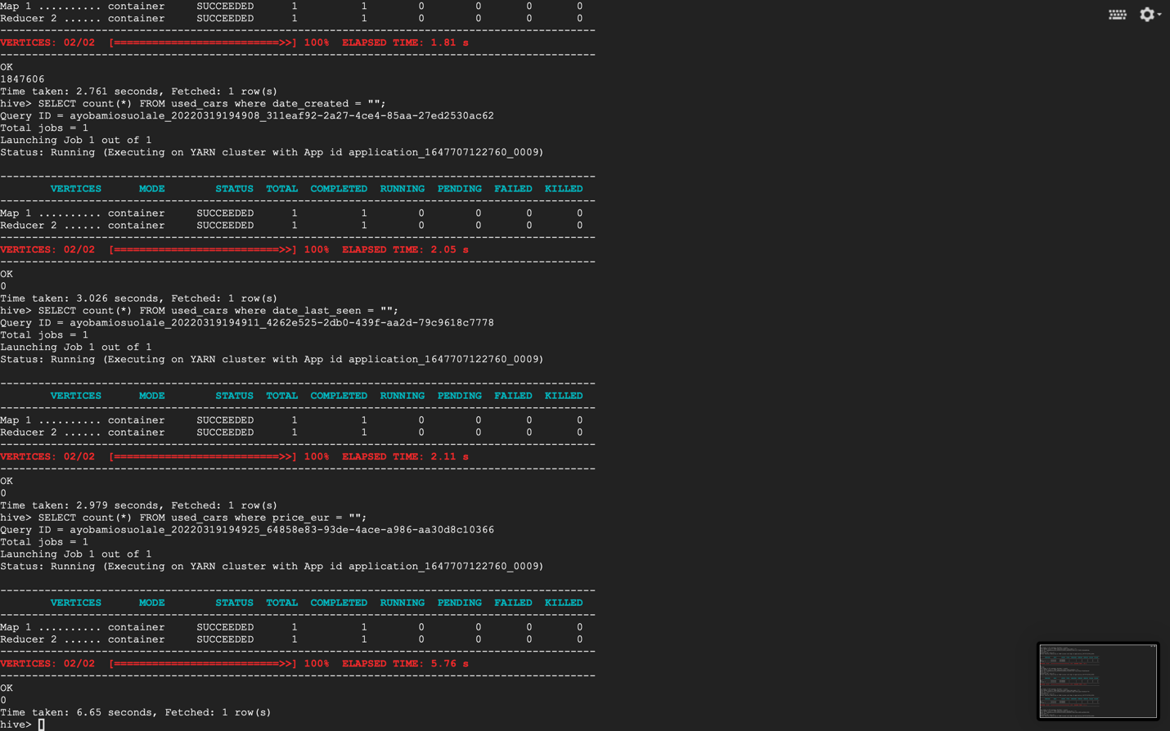

FIG. 7. CALCULATE NULL IN COLUMNS